**Instructions:**

Since this class is being streamed, and therefore you aren’t taking the exam “in person”, I expect this work to be done individually, and not in conjunction with any past or present students, faculty, or other people. However, you may use your class notes and textbooks to respond to these.

Respond completely, INSIDE THIS file itself, as I will be grading this exam inside the word document. Type up responses, draw diagrams, respond fully. Take screenshots, make illustrations, take as much space as you need. Answer completely. State assumptions. Do what you need to in order to demonstrate understanding and mastery of this material. Note, the last page is a coding part of the exam, which also needs to be done and submitted. Look at instructions. Pay attention to directions.

**Performance Evaluation of Parallelization**

In class, we derived and discussed this inequality for speedup. (this is the notation used in class and also by the Quinn textbook).

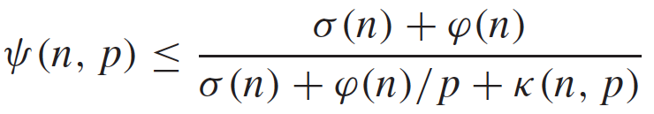

Define each term here, and does it represent and where does it come from?

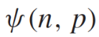 = speedup of problem with size n on p processors. It is less than or equal to the time the problem takes when running only serially divided by the time the problem takes when the parallelizable portion is run on p processors in parallel.

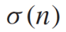 = time of serial portion of the problem with size n.

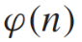 = time of parallelizable portion of the problem with size n.

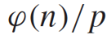 = time of parallelizable portion of the problem with size n, divided by number of processors, p.

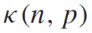 = time required for parallel overhead given problem size n and number of processors p.

What does the numerator above represent? What does the denominator represent?

The numerator above represents the time that the program takes to complete the problem when running sequentially, or on a single processor.

The denominator above represents the time that the program takes to complete the problem when the parallelizable portion is divided amongst p number of processors.

Define efficiency.

Efficiency is a measure of processor utilization. It is equal to the speedup divided by the number of processors.

What does  represent, and is it better for this to be a close to 0 or close to 1, and why ?

 represents the percentage or portion of the entire computation that is inherently sequential.

It would be ideal that this portion is closer to 0, meaning that almost the entire program can be run in parallel, thus allowing for greater speedup.

Consider these predictions of speedup:

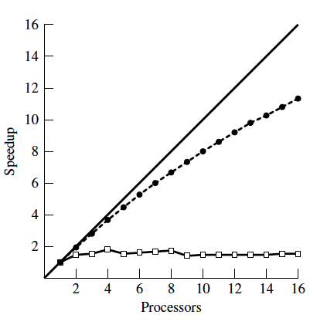



What does the ‘a’ curve *likely* represent? Why is it important?

The ‘a’ curve represents ideal speedup. This is important as it is a strict upper bound for speedup that is truly only attainable when a problem is completely parallelizable and requires no time for parallel overhead.

Of curves b and c, one of these curves includes a non-zero k(n,p) term. Which term assumes k(n,p) is 0, and which does not, and why?

Curve b has a non-zero k(n,p) term, which means that it is, in fact, accounting for time taken in parallel overhead. We can tell that this is true, as the rate of change in speedup decreases as the number of processors increases.

Curve c on the other hand does have a k(n,p) term of 0. We can tell that this is true as the speedup is constant and the slope of the curve does not decrease as the number of processors increases.

Consider these observed measures of obtained speedup:

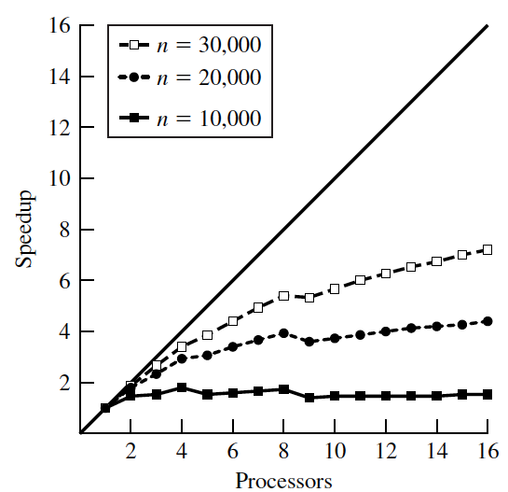

We have seen that as the problem size increases, our measured speedups tend to improve for a fixed number of processors. Why is this? What are some reasons this could be?

This is because increasing the problem size increases the computation time faster than it increases the communication time. What this means is that the ratio between sequential and parallel time increases, increasing the percentage of the entire problem that is parallelizable, thus allowing for greater speedup.

A reason that this could occur would be that we have a program where the time taken in overhead only increases as a function of the number of processors, not the problem size. When the size of the problem increases, there is no extra time taken in communication between processors but, the percentage of the problem that is parallelizable increases, giving the greater speedup on problems of greater size.

**Pointers / 2-D arrays / Memory Hierarchy**

Assuming that a 2D matrix is stored in memory using the allocation technique we made use of in class, specifically the

“void alloc2dnew(double*** a, int nrows, int ncols)”

function we used.

Assume the matrix is

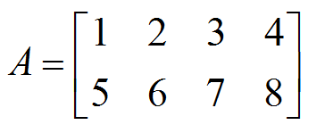

Assume A was declared and malloced from main() like this:

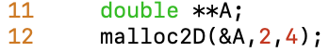

Sketch the entire 2D array structure, including the pointers, for how A is stored in memory, for the method we discussed in class, and have been using for our assignments so far. Show the variables on the stack and on the heap. Show individual pointers. Make up memory addresses, be consistent and also draw arrows for the pointers. Also besides your hand-drawn (or PPT drawn) sketches, also include a screenshot from the pointer visualization tool I showed in class at: <http://pythontutor.com/c.html#>.

(use as much space here as you need, add pages, if/when needed to be clear)

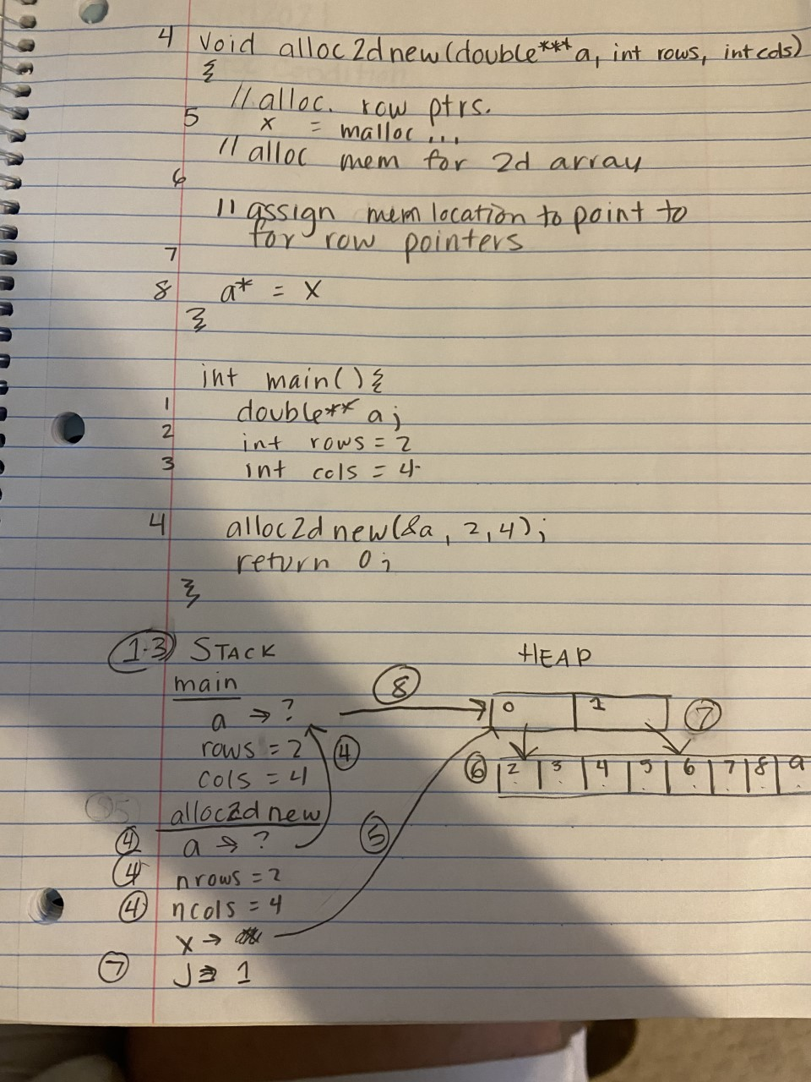

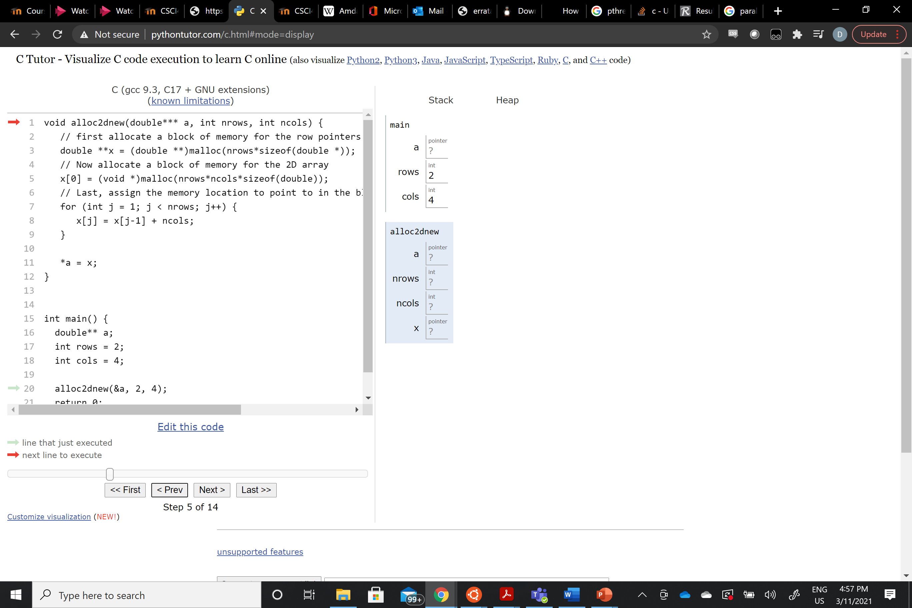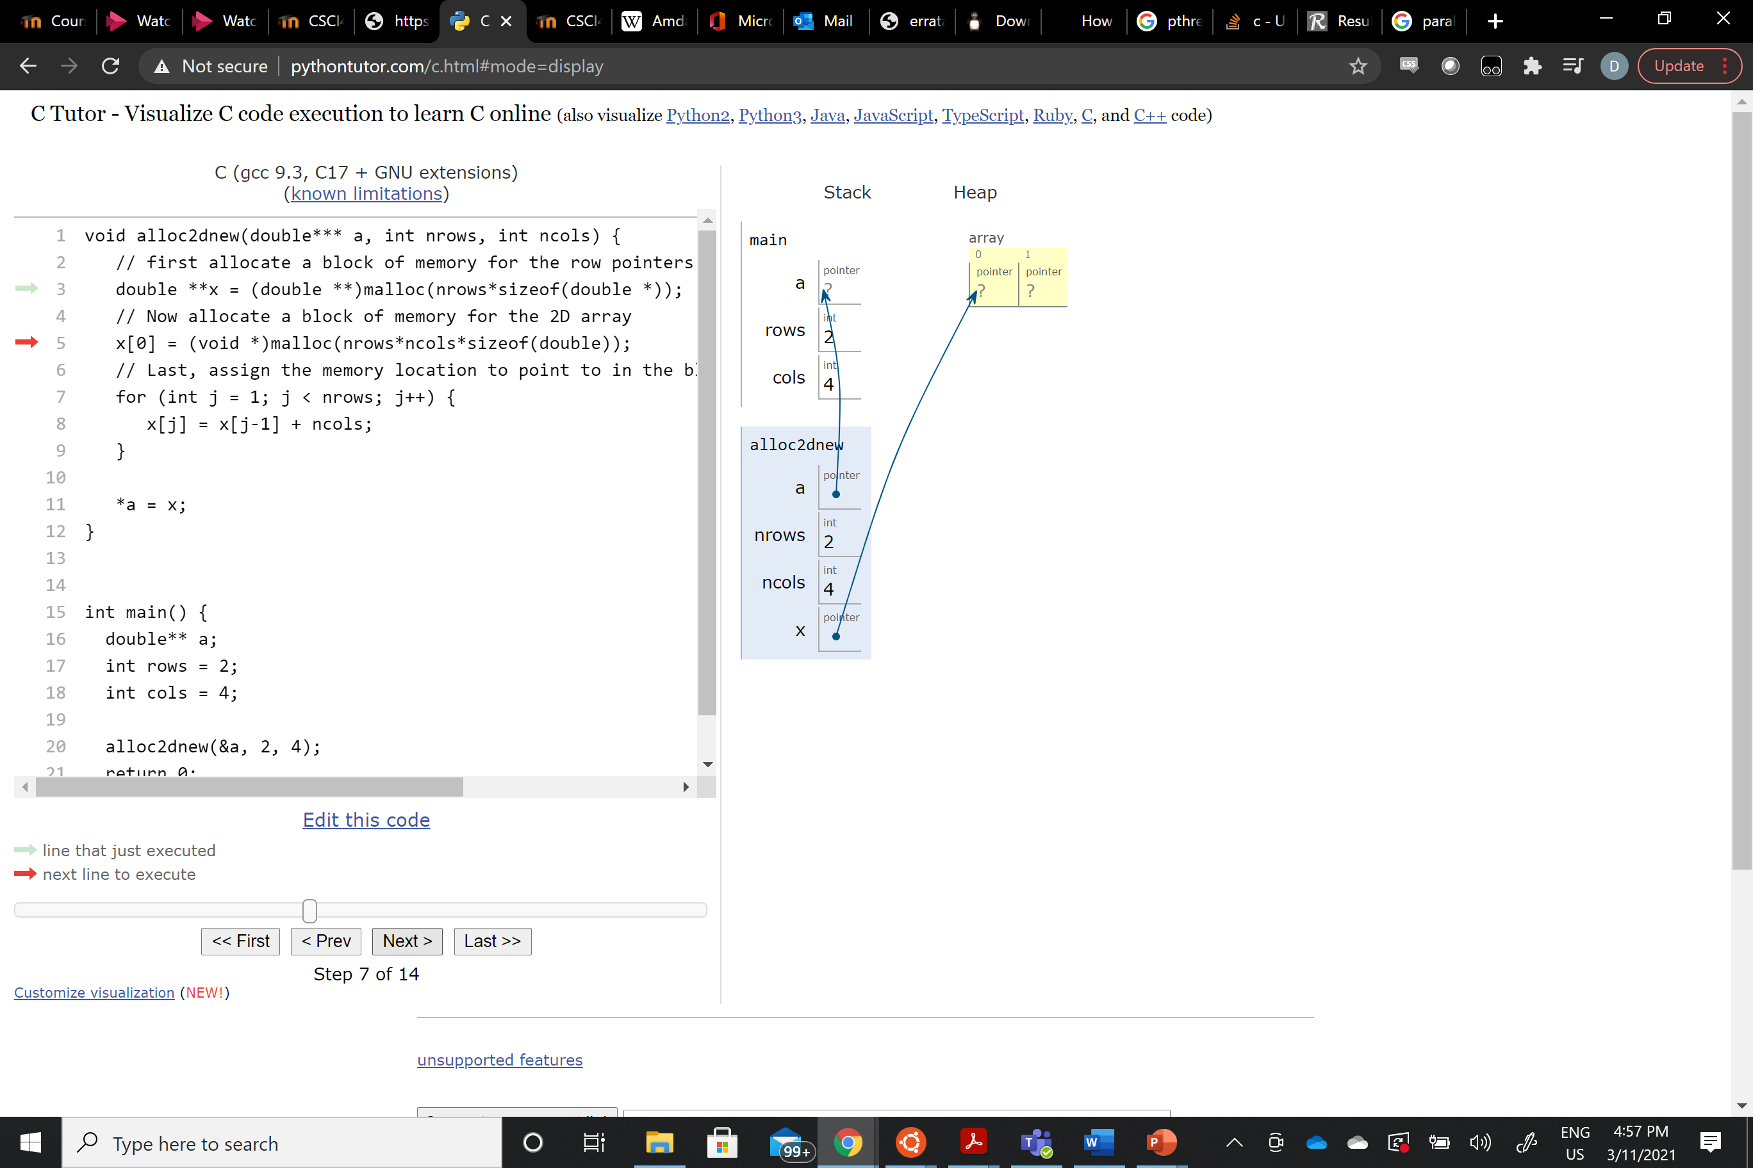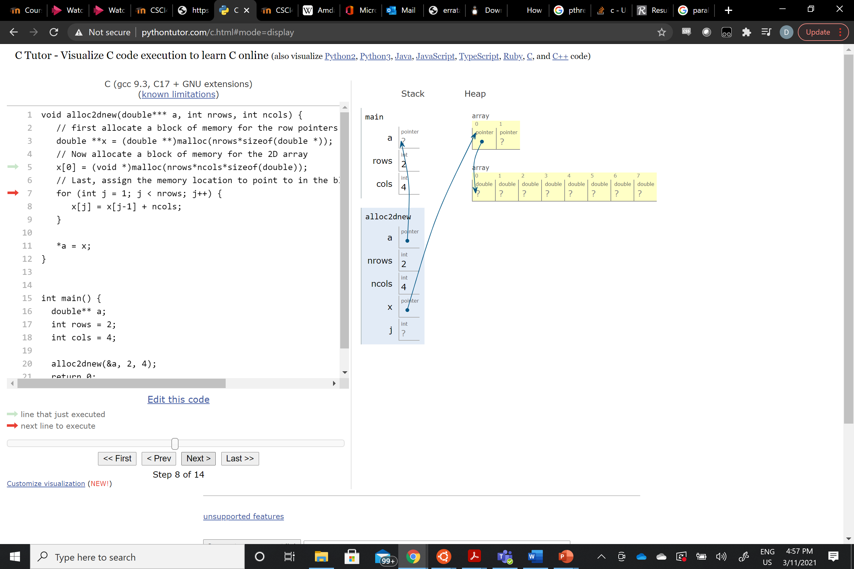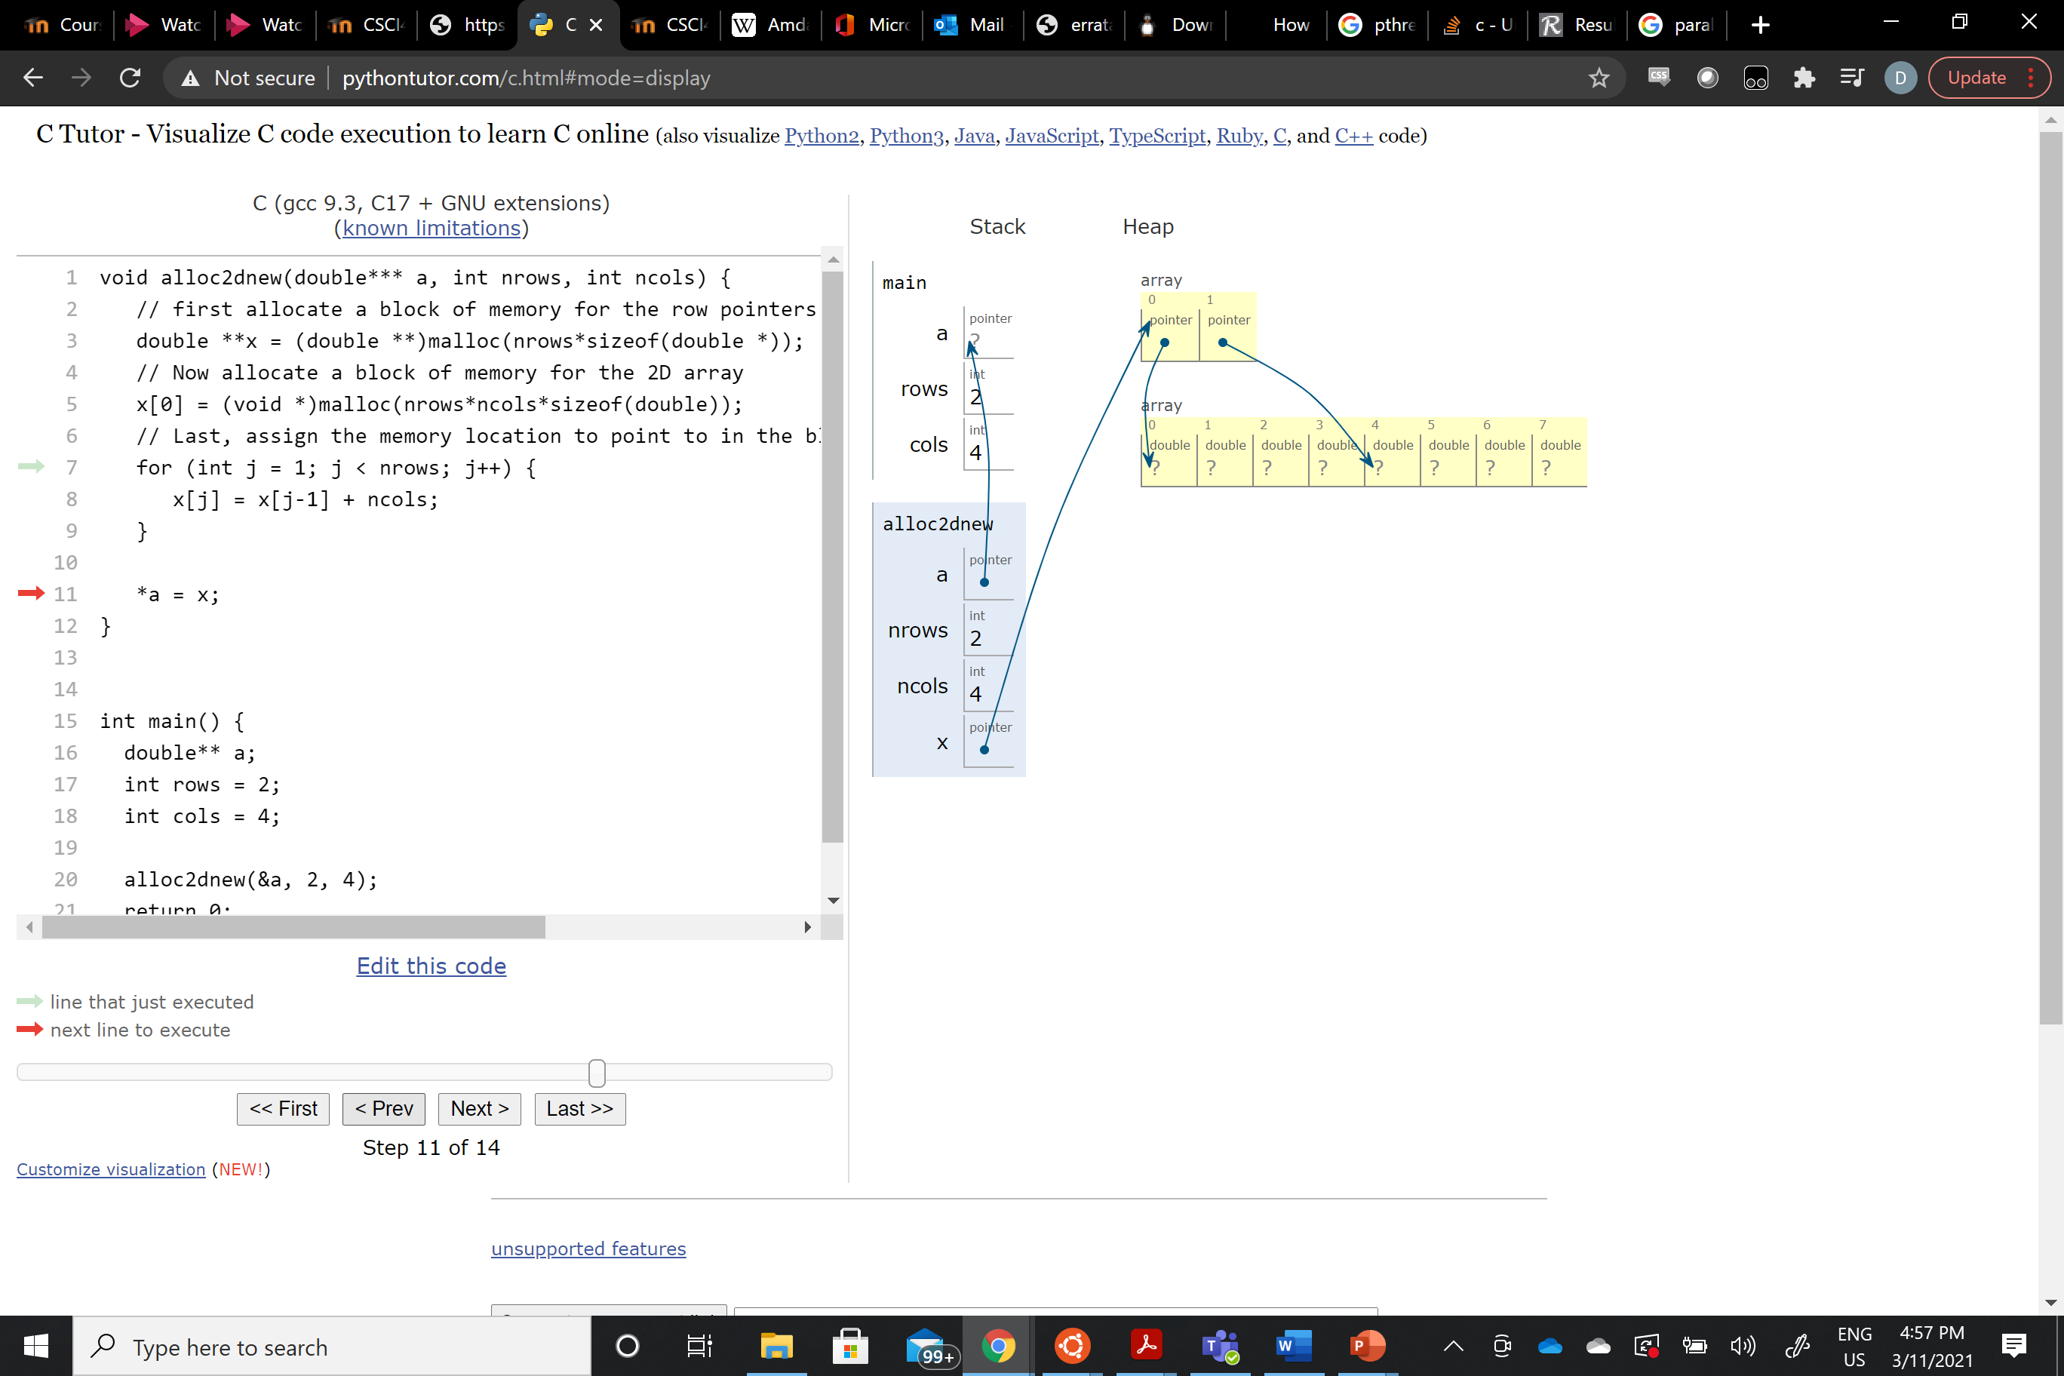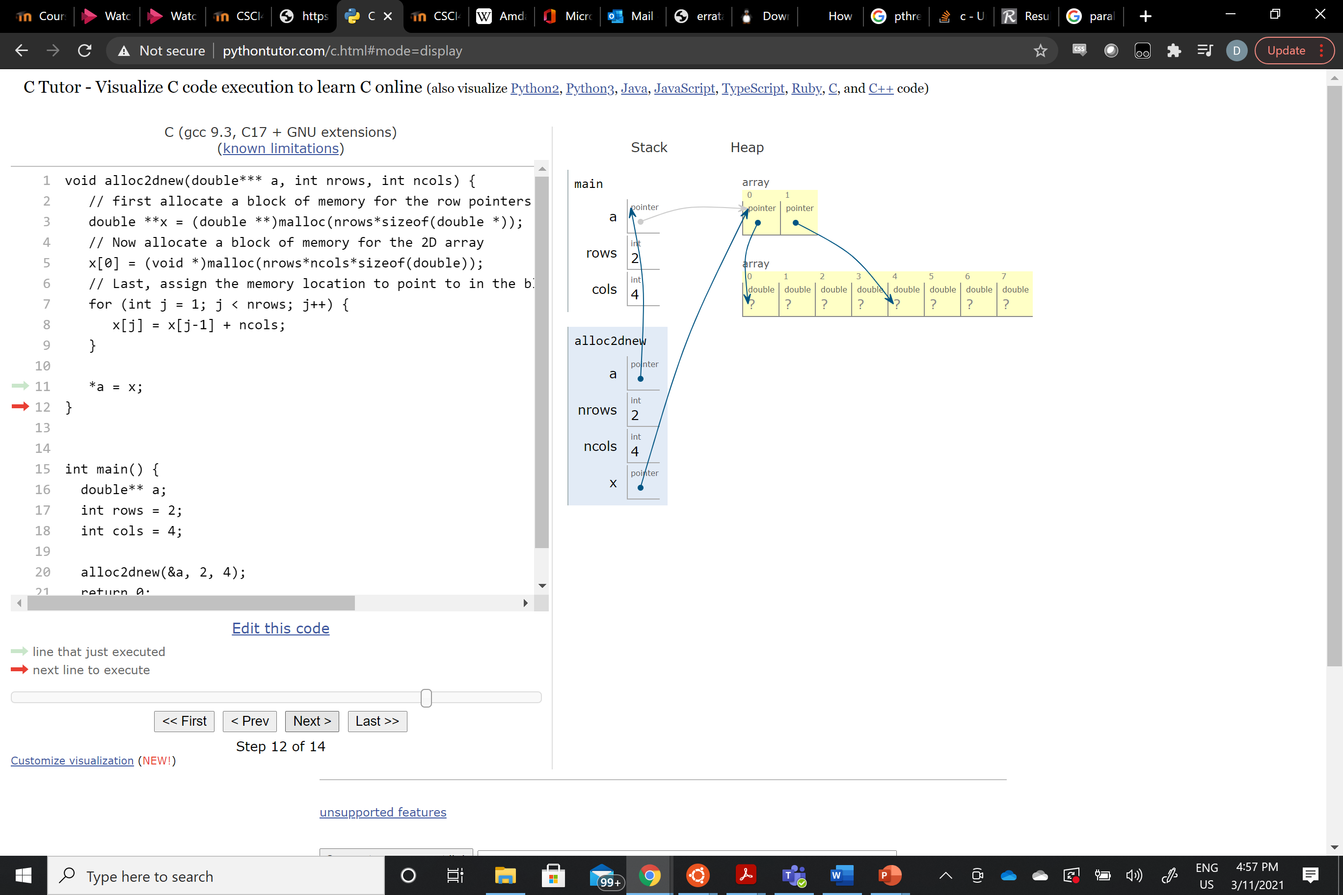

Given what we discussed in class and taking cache hierarchy into consideration, which of the following two versions of code would likely run faster for a large matrix A[m][n] (m rows, n cols), why, explain fully, sketch out the issue, etc. Explain the overarching issues, from a computer system point of view.

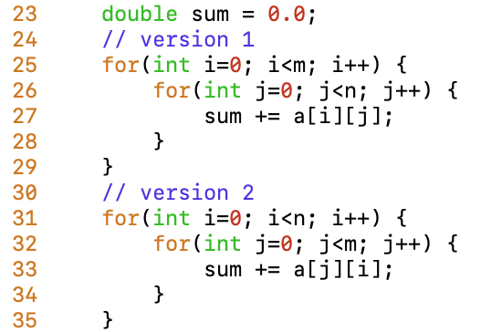

Version 1 would run faster, due to it traversing the matrix in row-major order. This is due to the fact that arrays in C are already stored in contiguous space in row-major order. So, by using this method, you are getting data from contiguous space in memory rather than jumping around to different locations. On top of that, our systems may fill our cache with memory addresses close to the ones we are currently accessing, but have not been used yet. When traversing in row-major order, since the memory is stored contiguously, the cache will already contain the address of the next location we are planning on going.

**MPI Programming**

As I discussed in class on [Thurs Mar 4, 2021](https://web.microsoftstream.com/video/4028a243-c30c-4e46-9e44-7bae88cd5e6c) , you will develop a Monte Carlo code that will perform definite integration of the three functions specified in class. (Make sure you go back and look at the video to make sure you completely understand what is being asked of you. You must implement this integration yourself, and must also parallelize it as we discussed).

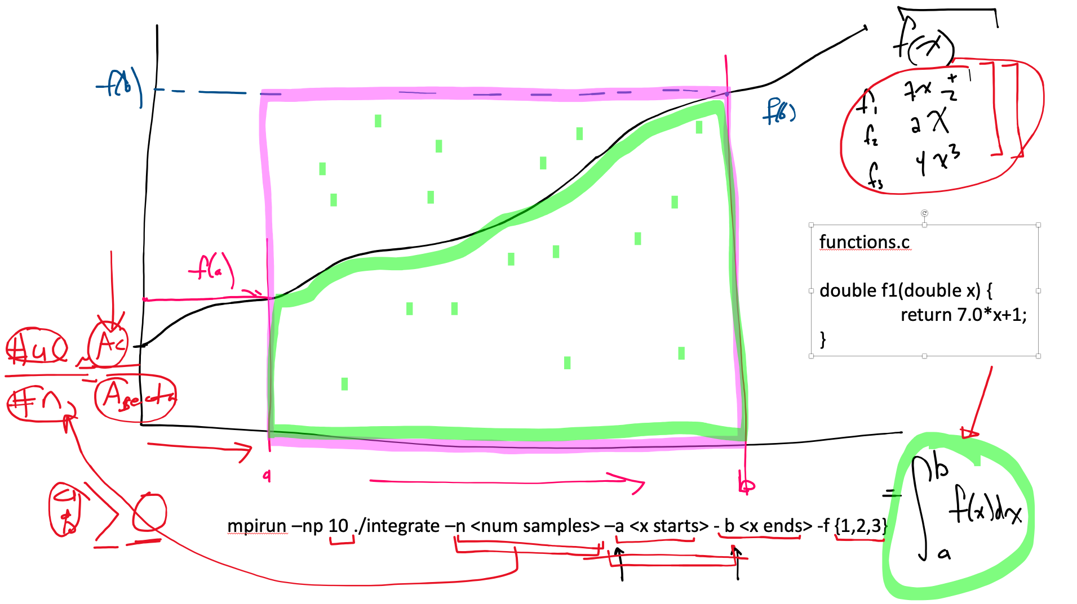

Your project will have the following files:

Makefile

integrate-serial.c // serial implementation (no MPI)

integrate-parallel.c // parallel implementation (MPI)

functions.c // at least contains the defs of f_i(x)

functions.h // prototypes for funcs in functions.c

These files will reside in a directory called “first_last_midterm”, where first and last are your first and last names, respectively.

The Makefile will be a properly formatted Makefile with both an 'all' and a 'clean' section.

the function interface is as follows:

./integrate-serial -n <num samples> -a <x start> -b <x end> -f <1, 2, or 3>

mpirun -np <p> ./integrate-parallel -n <num samples> -a <x start> -b <x end> -f <1, 2, or 3>

num samples is the total number of samples, regardless if in parallel or not, not the number of samples per process. Note you may want the number of samples to be in a variable that is larger than a 32-bit int, perhaps a 64-bit long, so that num samples can be really large, so you can get some timing data (see rest of document)

the a and b refer to the a and b in:

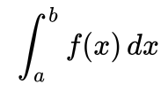

and the -f refers to which function we’re talking about integrating:

f1(x) = 7x + 1

f2(x) = 2x^2

f3(x) = 4x^3

Test your code on your own machine and on COMET or EXPANSE for 1, 2, 3, 4, 5, 8, 9, 10, and 16 processes. See note below about data collection for performance analysis.

Choose some different values of a and b for each function and show that the answers given by your programs converge the actual definite integrals for the given functions, by integrating by hand and showing the results. Show your work, etc in the report.

The output from your program execution should print out:

1. The function being integrated (in text) and also the limits of integration

2. The estimated answer as a double

3. The number of samples that were performed and for the MPI version, the number of processes

4. The overall amount of time spent in the program (for both the serial and parallel versions)

Collect data for the parallel version (T_overall) so that you can then provide an analysis for the S(n,p) (speedup) and E(n,p) efficiency, as a function of n (num samples) and also p (num processes), like we also discussed in class for Milestone 2 of the MV1 project.

Make timing plots, speedup plots and efficiency plots like those described in class, and [highlighted here](https://moodle.coastal.edu/pluginfile.php/1036785/mod_page/content/29/MV1-Milestone2.pptx). Specifically, for 4 different sample sizes (i.e. problem sizes) make the timing plots (4 of them, for p = 1, 2, 3, 4, 5, 8, 9, 10, and 16 processes) and then also the speedup plots (1 plot with the ideal shown, and also the 4 curves for the 4 different n’s, with the same range of p’s 1, 2, 3, 4, 5, 8, 9, 10, and 16 processes) and efficiency plots (same as in speedups).

I made a big deal in class about what I was talking about for each of types of plots.

Make sure all files reside in your directory.

**Report in Midterm:**

**Discuss your code, provide screenshots, show example output demonstrating that it works.**

To submit your project, you must tar gzip your project directory, and it's contents by:

tar cf - ./first_last_midterm | gzip > first_last_midterm.tar.gz

INCLUDE THIS FILE with your responses in it, inside this TAR GZ.

PUT ALL YOUR FILES, anything that you used (data, plotting, etc).

You will perform this operation from the parent directory of “ first_last_midterm”.

Submit your tar.gz files on Moodle by the time and date indicated. No late work will be accepted. (will be submitted along with your solution to the exam)

**PUT INTEGRATION CODE / PROJECT REPORT HERE –**

**err on the side of too detailed as opposed to not enough**

The integration code works by using the Monte Carlo method for estimating the area under a curve produced by some monotonically increasing function f(x), under some upper and lower bounds on the x-axis. This is done by creating a rectangle around the curve, with the sides being placed at the upper and lower bounds input into the function, the bottom side of the rectangle being the x-axis, the top side of the rectangle being bound by f(x) where x is the upper bound input placed on x. The rectangle is now partitioned off into two sections, one that is above the curve and one that is under the curve. Then we are randomly generating an ordered pair (x,y) from a uniform distribution, where the x-value is bounded by our x-axis input bounds, and the y-value is bounded by the y-axis and the top of the rectangle. These ordered pairs are then checked against the curve and determined to be either above or below the curve, and a count is kept of those that fall below the curve. The estimation comes from the fact that the ratio of the points that fall under the curve to those that are above the cure will approach the ratio of area under the curve to the area under the rectangle, calculated by the width times the height of the rectangle, as the number of ordered pairs approaches infinity. So, to get the approximation of the integral, we multiply the ratio of ordered pairs by the area of the rectangle. Below can be seen the accuracy of the program for 1,000,000 samples.

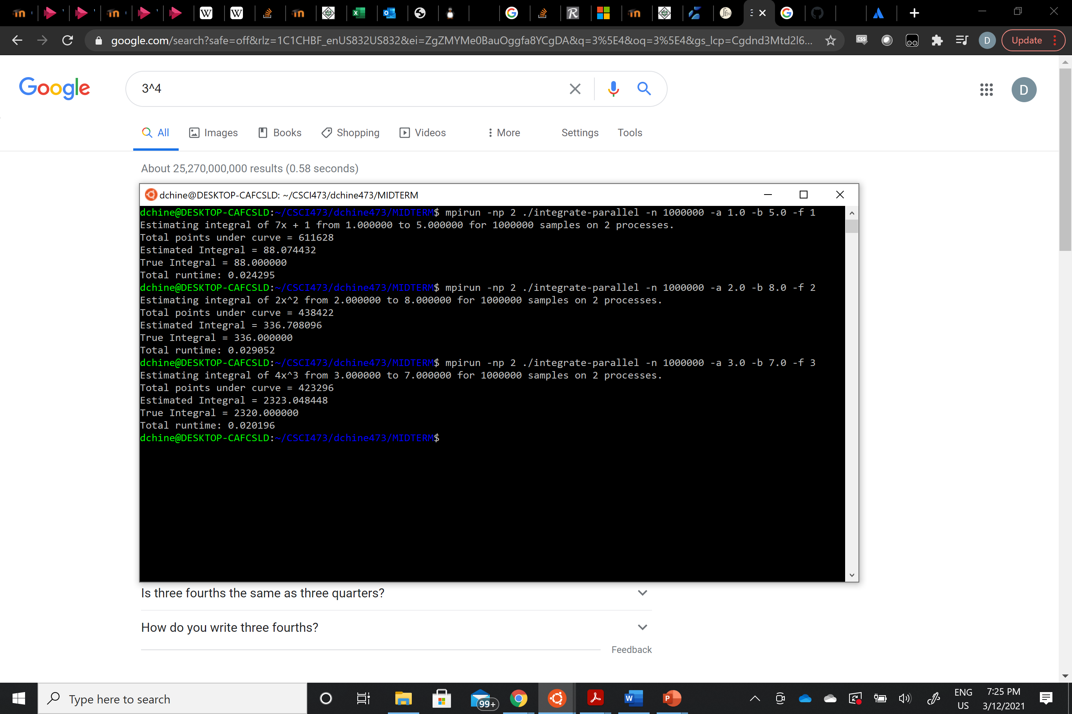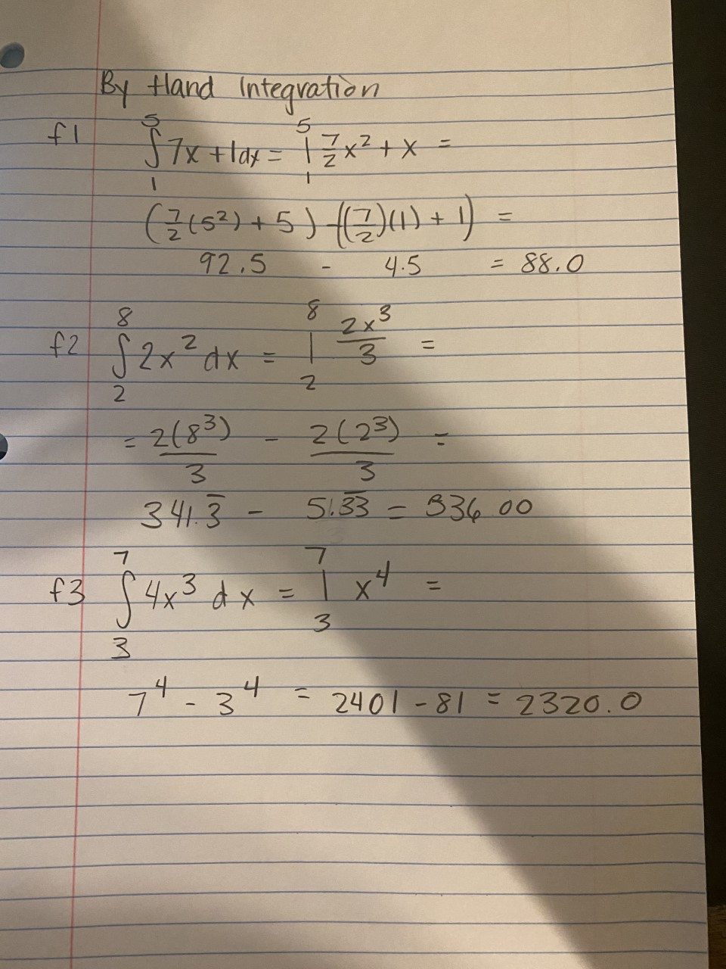

In parallelizing this program, I divided the number of samples to be run by the number of processors input, and then allowed each processor to compute that portion of the computation, while recording the number of points that fell under the curve within each process. Afterwards, using MPI_Reduce, I summed up the value that each processor held for the number of points under the curve for a total, which was then multiplied by the area of the rectangle and divided by the number of total samples over all processes to attain the final estimate of the area under the curve.

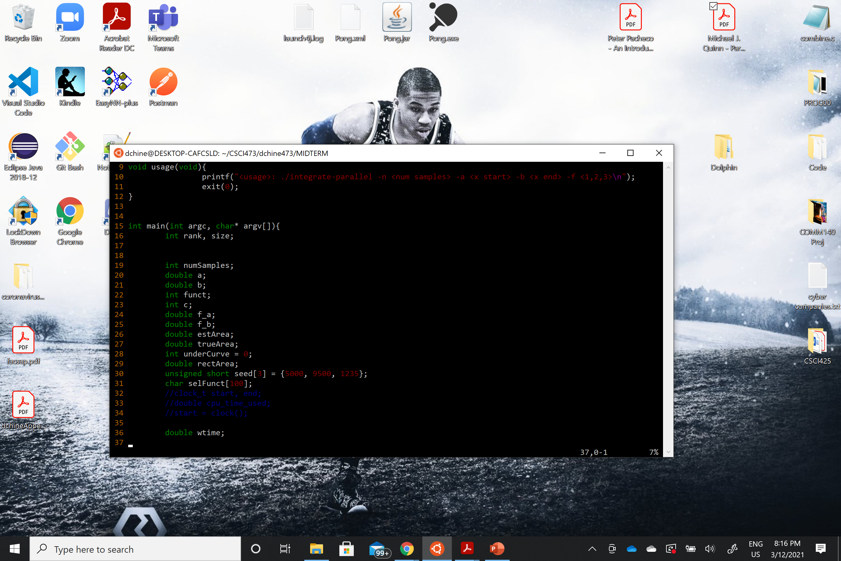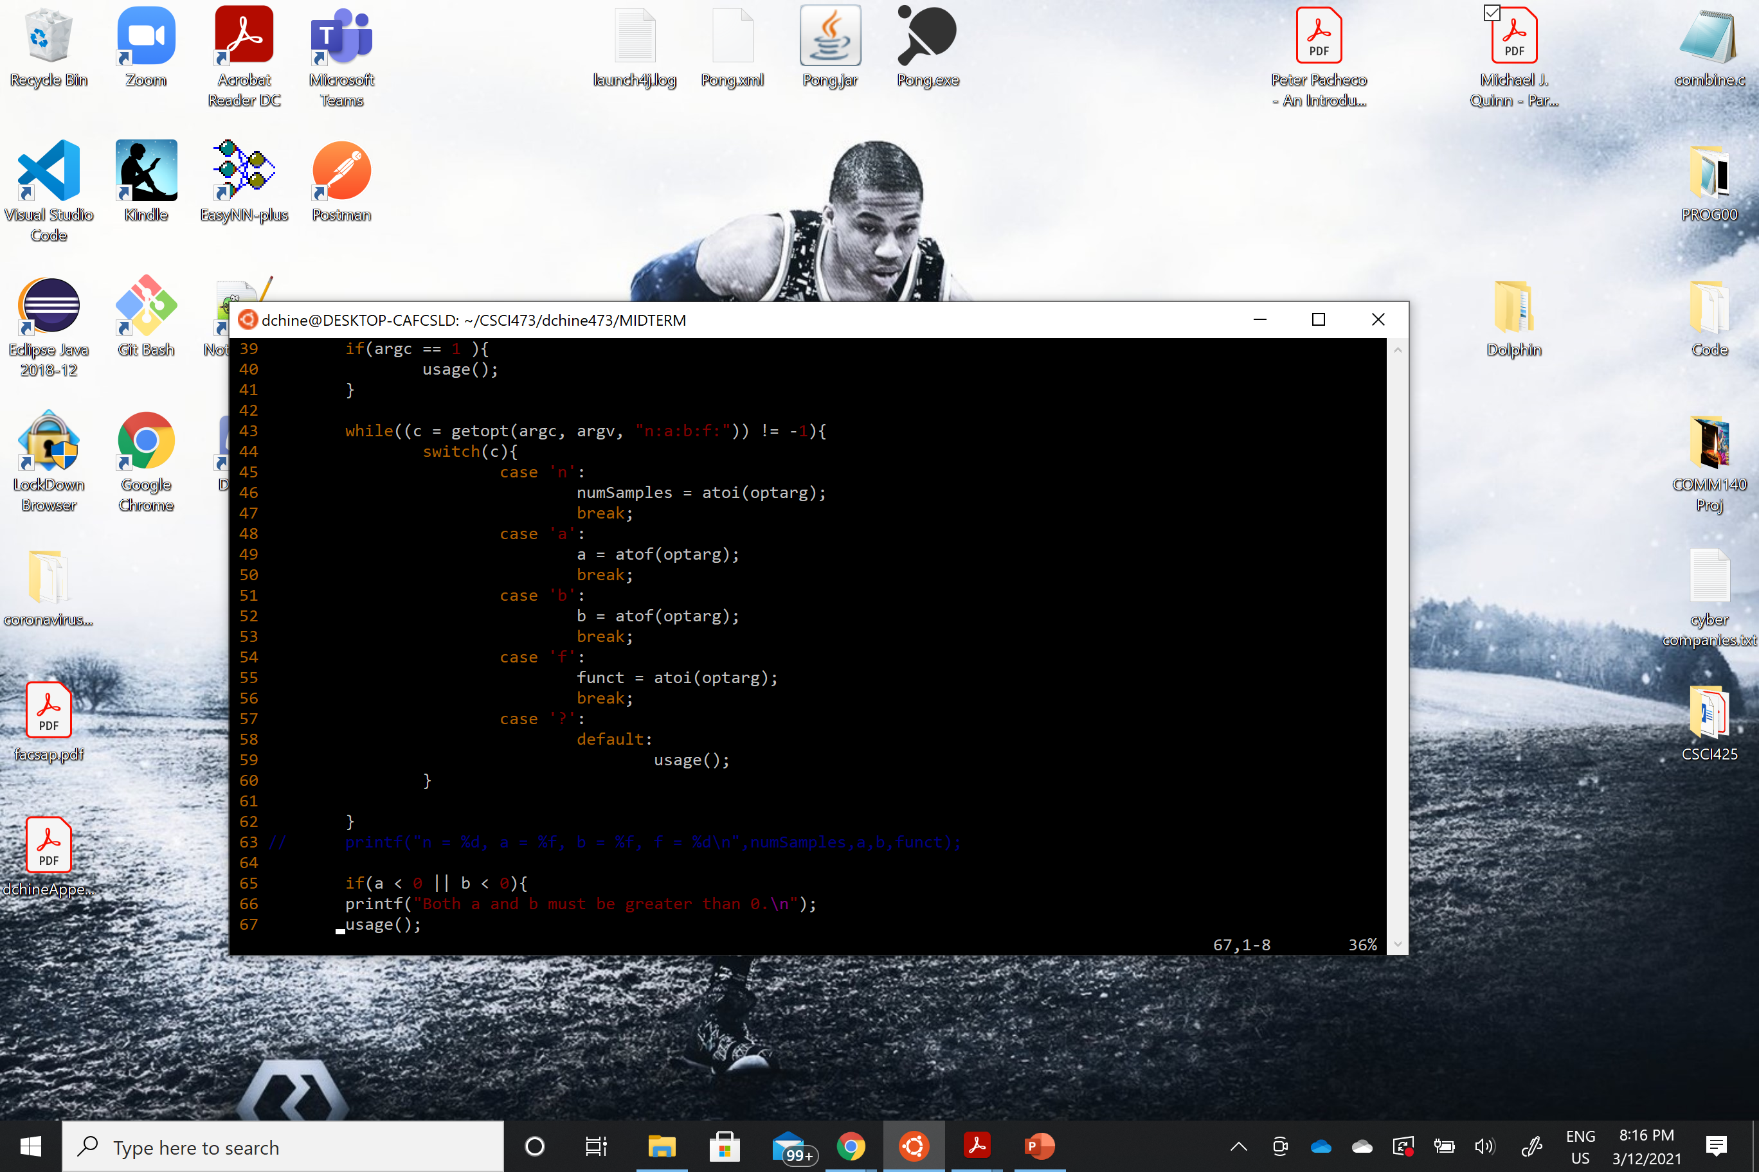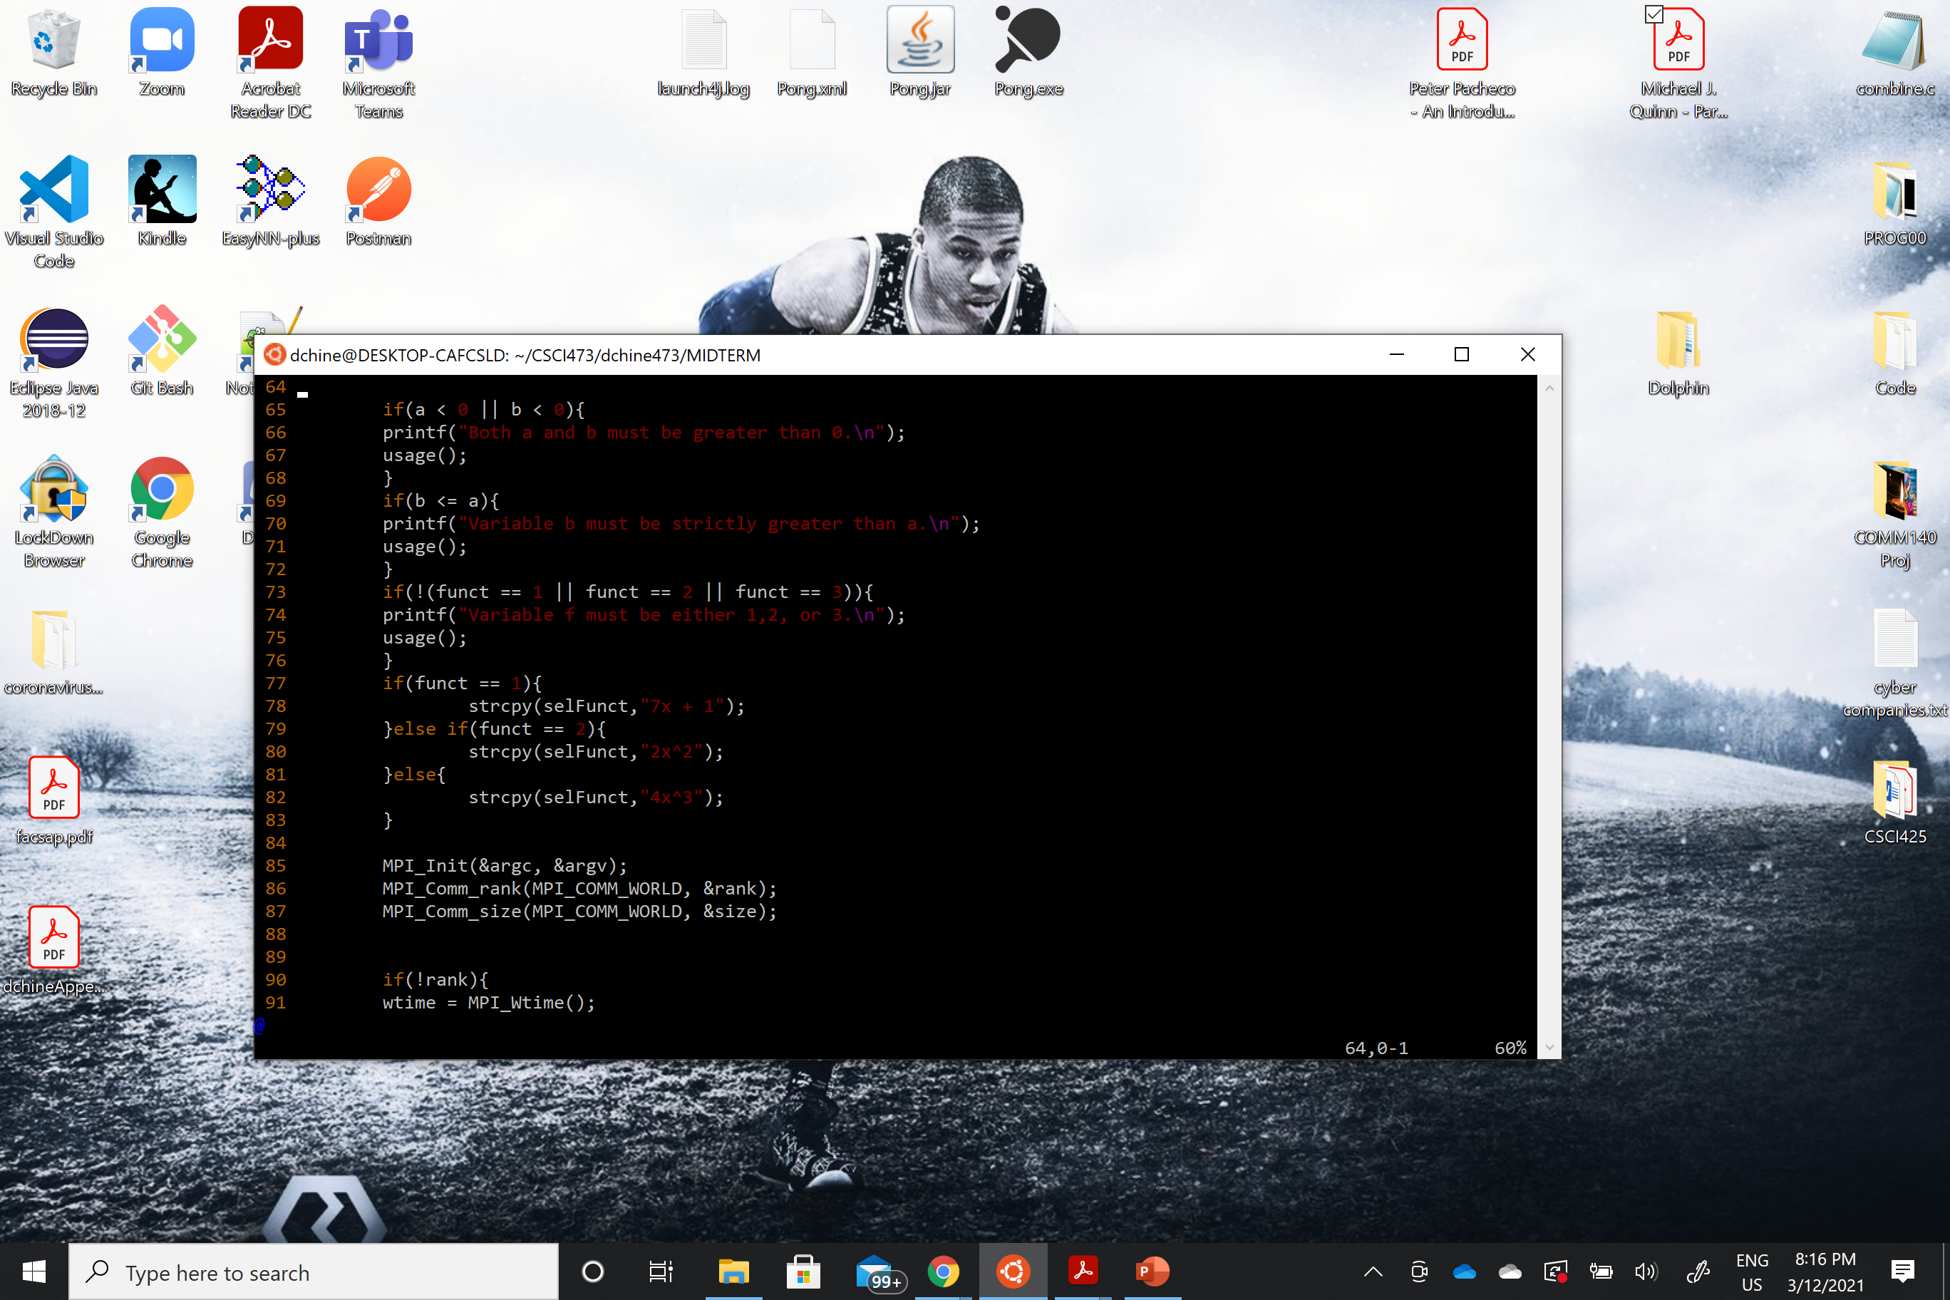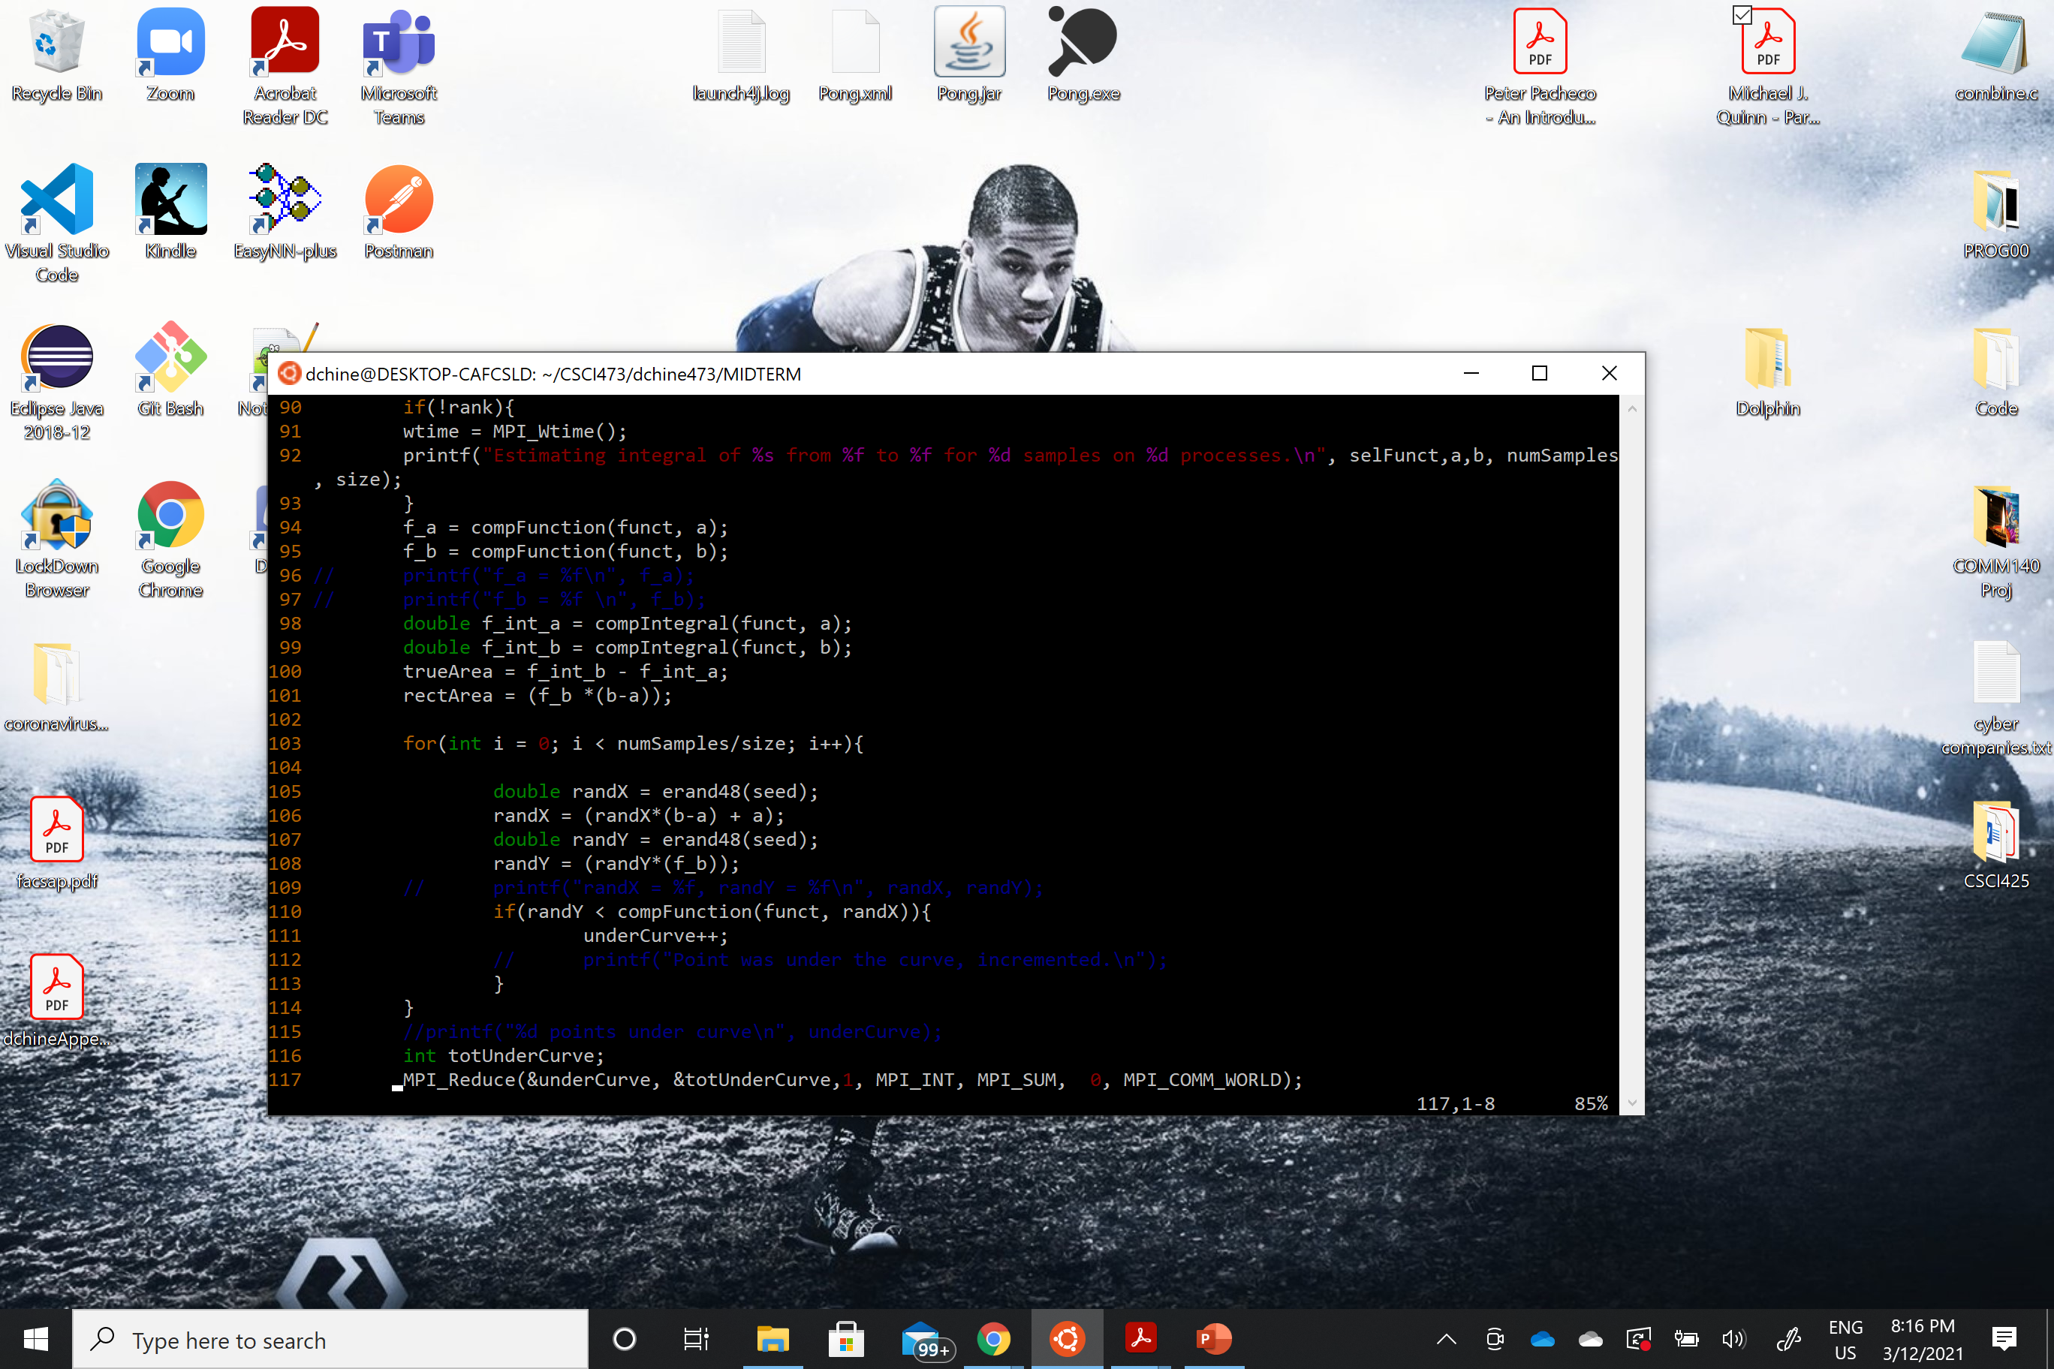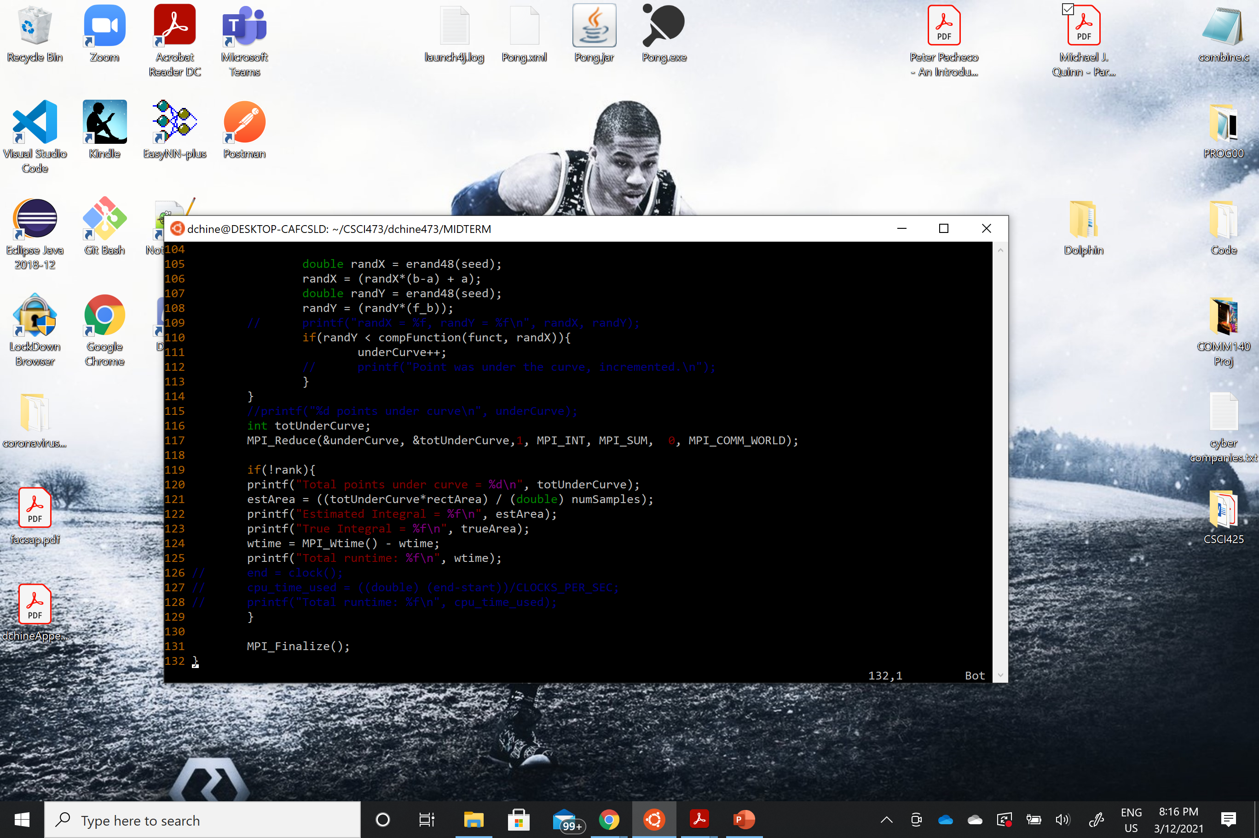

PERFORMANCE:

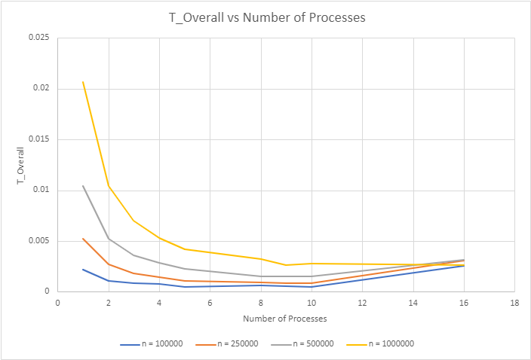

In the chart above, we have plotted the overall time that the program took vs the number of processors it was run on for four different sample sizes, n = 100000 samples, 250000 samples, 500000 samples, and 1000000 samples. We can see that as the number of processes increases, for each sample size, the T_Overall decreasingly, exponentially decays, and after about 10 processes there is a very small gradual increase in T_Overall. The decay in total time taken is due to the sampling being parallelized over the number of processes used, and the increase at the higher end of processes is likely due to the increased amount of parallel overhead. We also can note that this decay in overall time taken is more rapid in the cases where we have a higher sample size, which alludes to the next plot charting speedup.

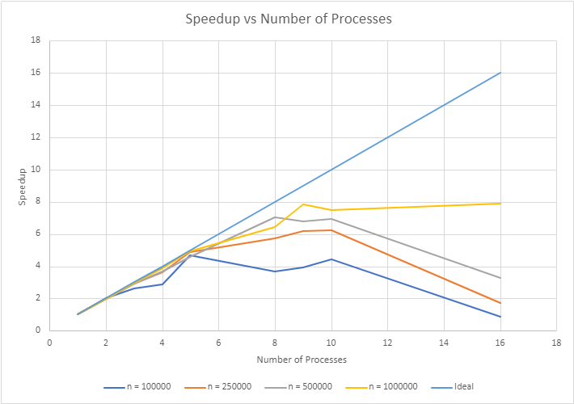

Somewhat antithetical to our chart of overall time against number of processes is our chart of speedup against number of processes. This is due to the fact that speedup is calculated by dividing the time taken running our program serially (one process) by the time taken running in parallel on p, processes. Again, we see that the curve takes somewhat of an exponential decay form, but this time increasingly. Like on the former curve, our program running with the largest sample size is the one most drastically effected. As the sample size increases, so does speedup (generally speaking) for a fixed number of processes. We also have, for reference, a curve showing what ideal speedup looks like, that is, where speedup is equal to the number processes. That being said, we again have the appearance of a decline in speedup as the number of processes grows greater than 10.

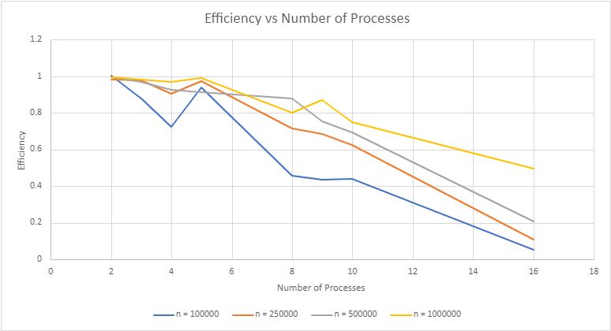

The last chart included is that of efficiency plotted against the number of processes for each of our sample sizes. Efficiency is calculated by dividing the speedup by the number of processes used. We can see that as the number of processes increase our efficiency does decrease. That being said, we should not forget that as the number of processes increases, time taken decreases. But when taking both of these factors into account, we can find a “sweet spot” where our system is running efficiently and producing a significant reduction in time for our problem size.